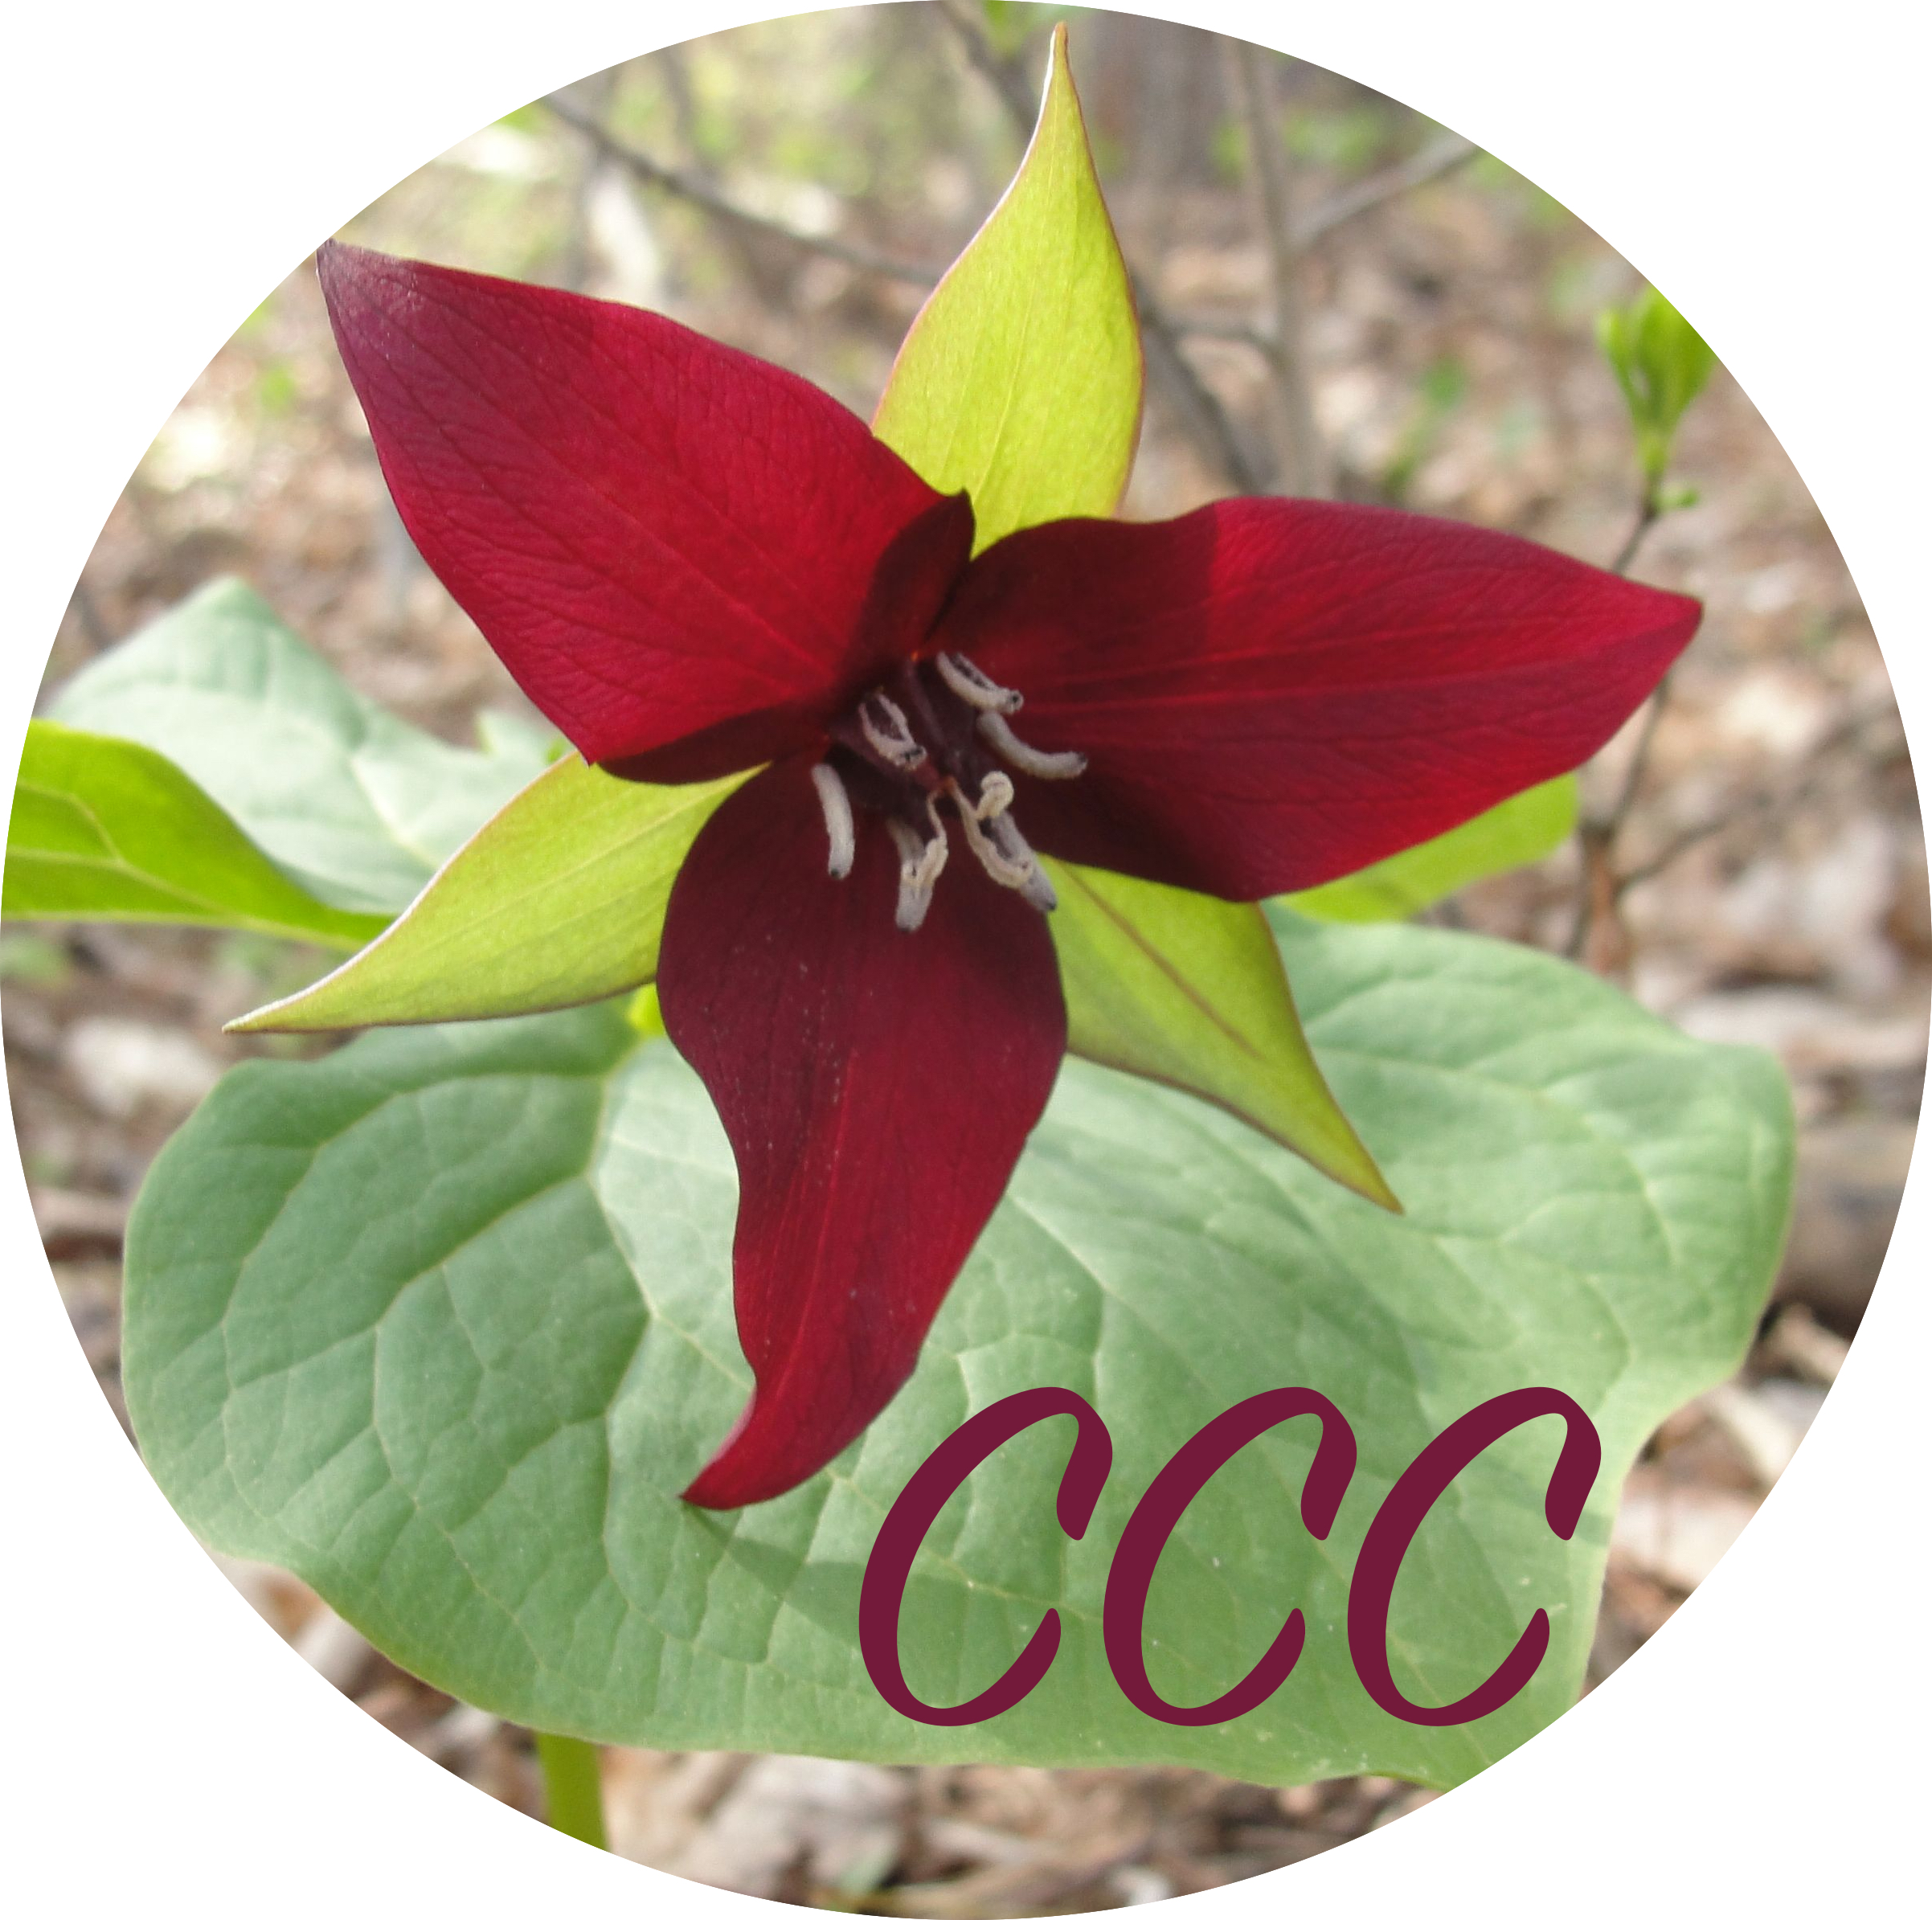
Teaching Reflection

Promoting a Positive Learning Environment

How did I demonstrate mutual respect for, rapport with, and responsiveness to students with varied needs and backgrounds, and challenge students to engage in learning?

Engaging Students in Learning
How did I engage students in developing: artistic skills (e.g., self expression, creativity, exploration/improvisation), knowledge (e.g., tools/instruments, technical proficiencies, processes, elements, organizational principles), contextual understandings (e.g., social, cultural, historical, global, personal reflection)?

Deepening Student Learning during Instructional Rehearsals

How did I evoke student responses through performances, exercises, and/or discussions and facilitated responses that supported students’ development and application of artistic skills, knowledge, and/or contextual understandings?

How did use modeling, demonstrations, and/or content examples to develop students’ artistic skills, knowledge, and/or contextual understandings for creating, performing, or responding to music?

Analyzing Teaching

How did my instruction support learning for the whole class and students who need greater support or challenge?

What changes will I make to my instruction to better support student learning of the central focus (e.g., missed opportunities)?

Why do I think these changes would improve student learning?

