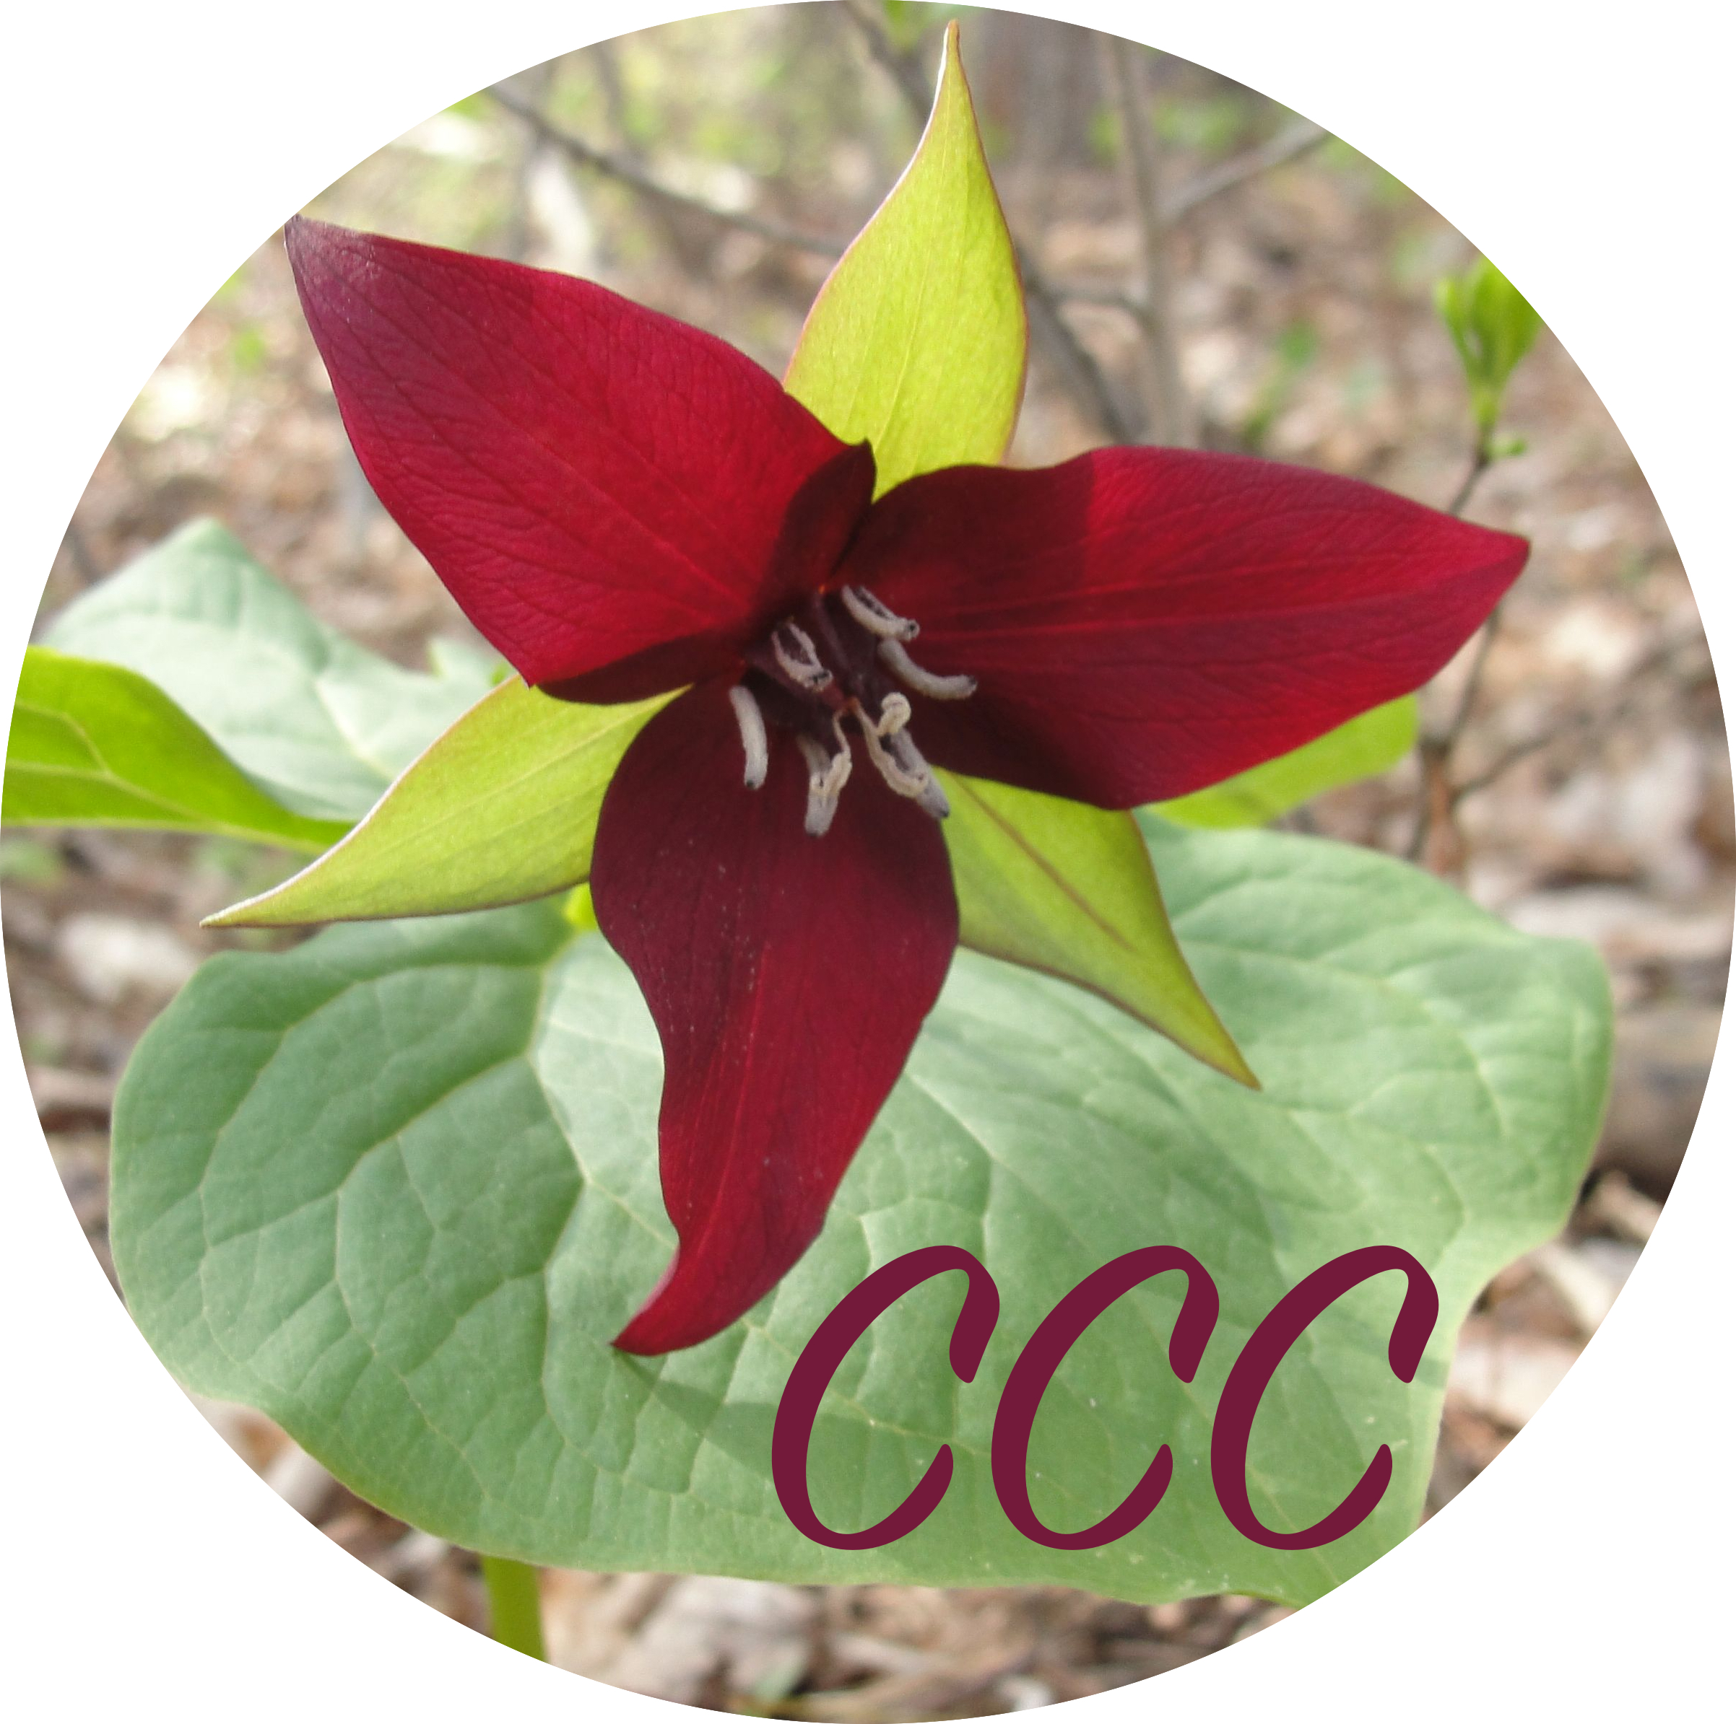
Responding Team_______________________________________
Step 1: Meet the members of your team to discuss and plan your individual and team contributions.
Goal: To plan, create, and present a contribution that will benefit our ensemble by responding, listening, discussing, sharing, moving, drawing, or dancing.
- Who are the members of your team? __________________________________________________________________________________________________________________________________________________________________________________________________________________
- Which piece of music are you most curious about? _________________________________________________________________________________________________________
- Describe what your team will do to contribute to our understanding and responding to this piece of music? ____________________________________________________________________________________________________________________________________________________________________________________________________________________________________________________________________________________________________________________________________________________________________________________________________________________________________
- Describe the steps your team will take and responsibilities each person will have in order to complete your team’s contributions: ______________________________________________________________________________________________________________________________________________________________________________________________________________________________________________________________________________________________________________________________________________________________________________________________________________________________________________________________________________________________________________________________________________________________________________________________________________________________________________________________________________________________________________________________________________________________
- Date you would like to present your team contributions: _______________________________________

