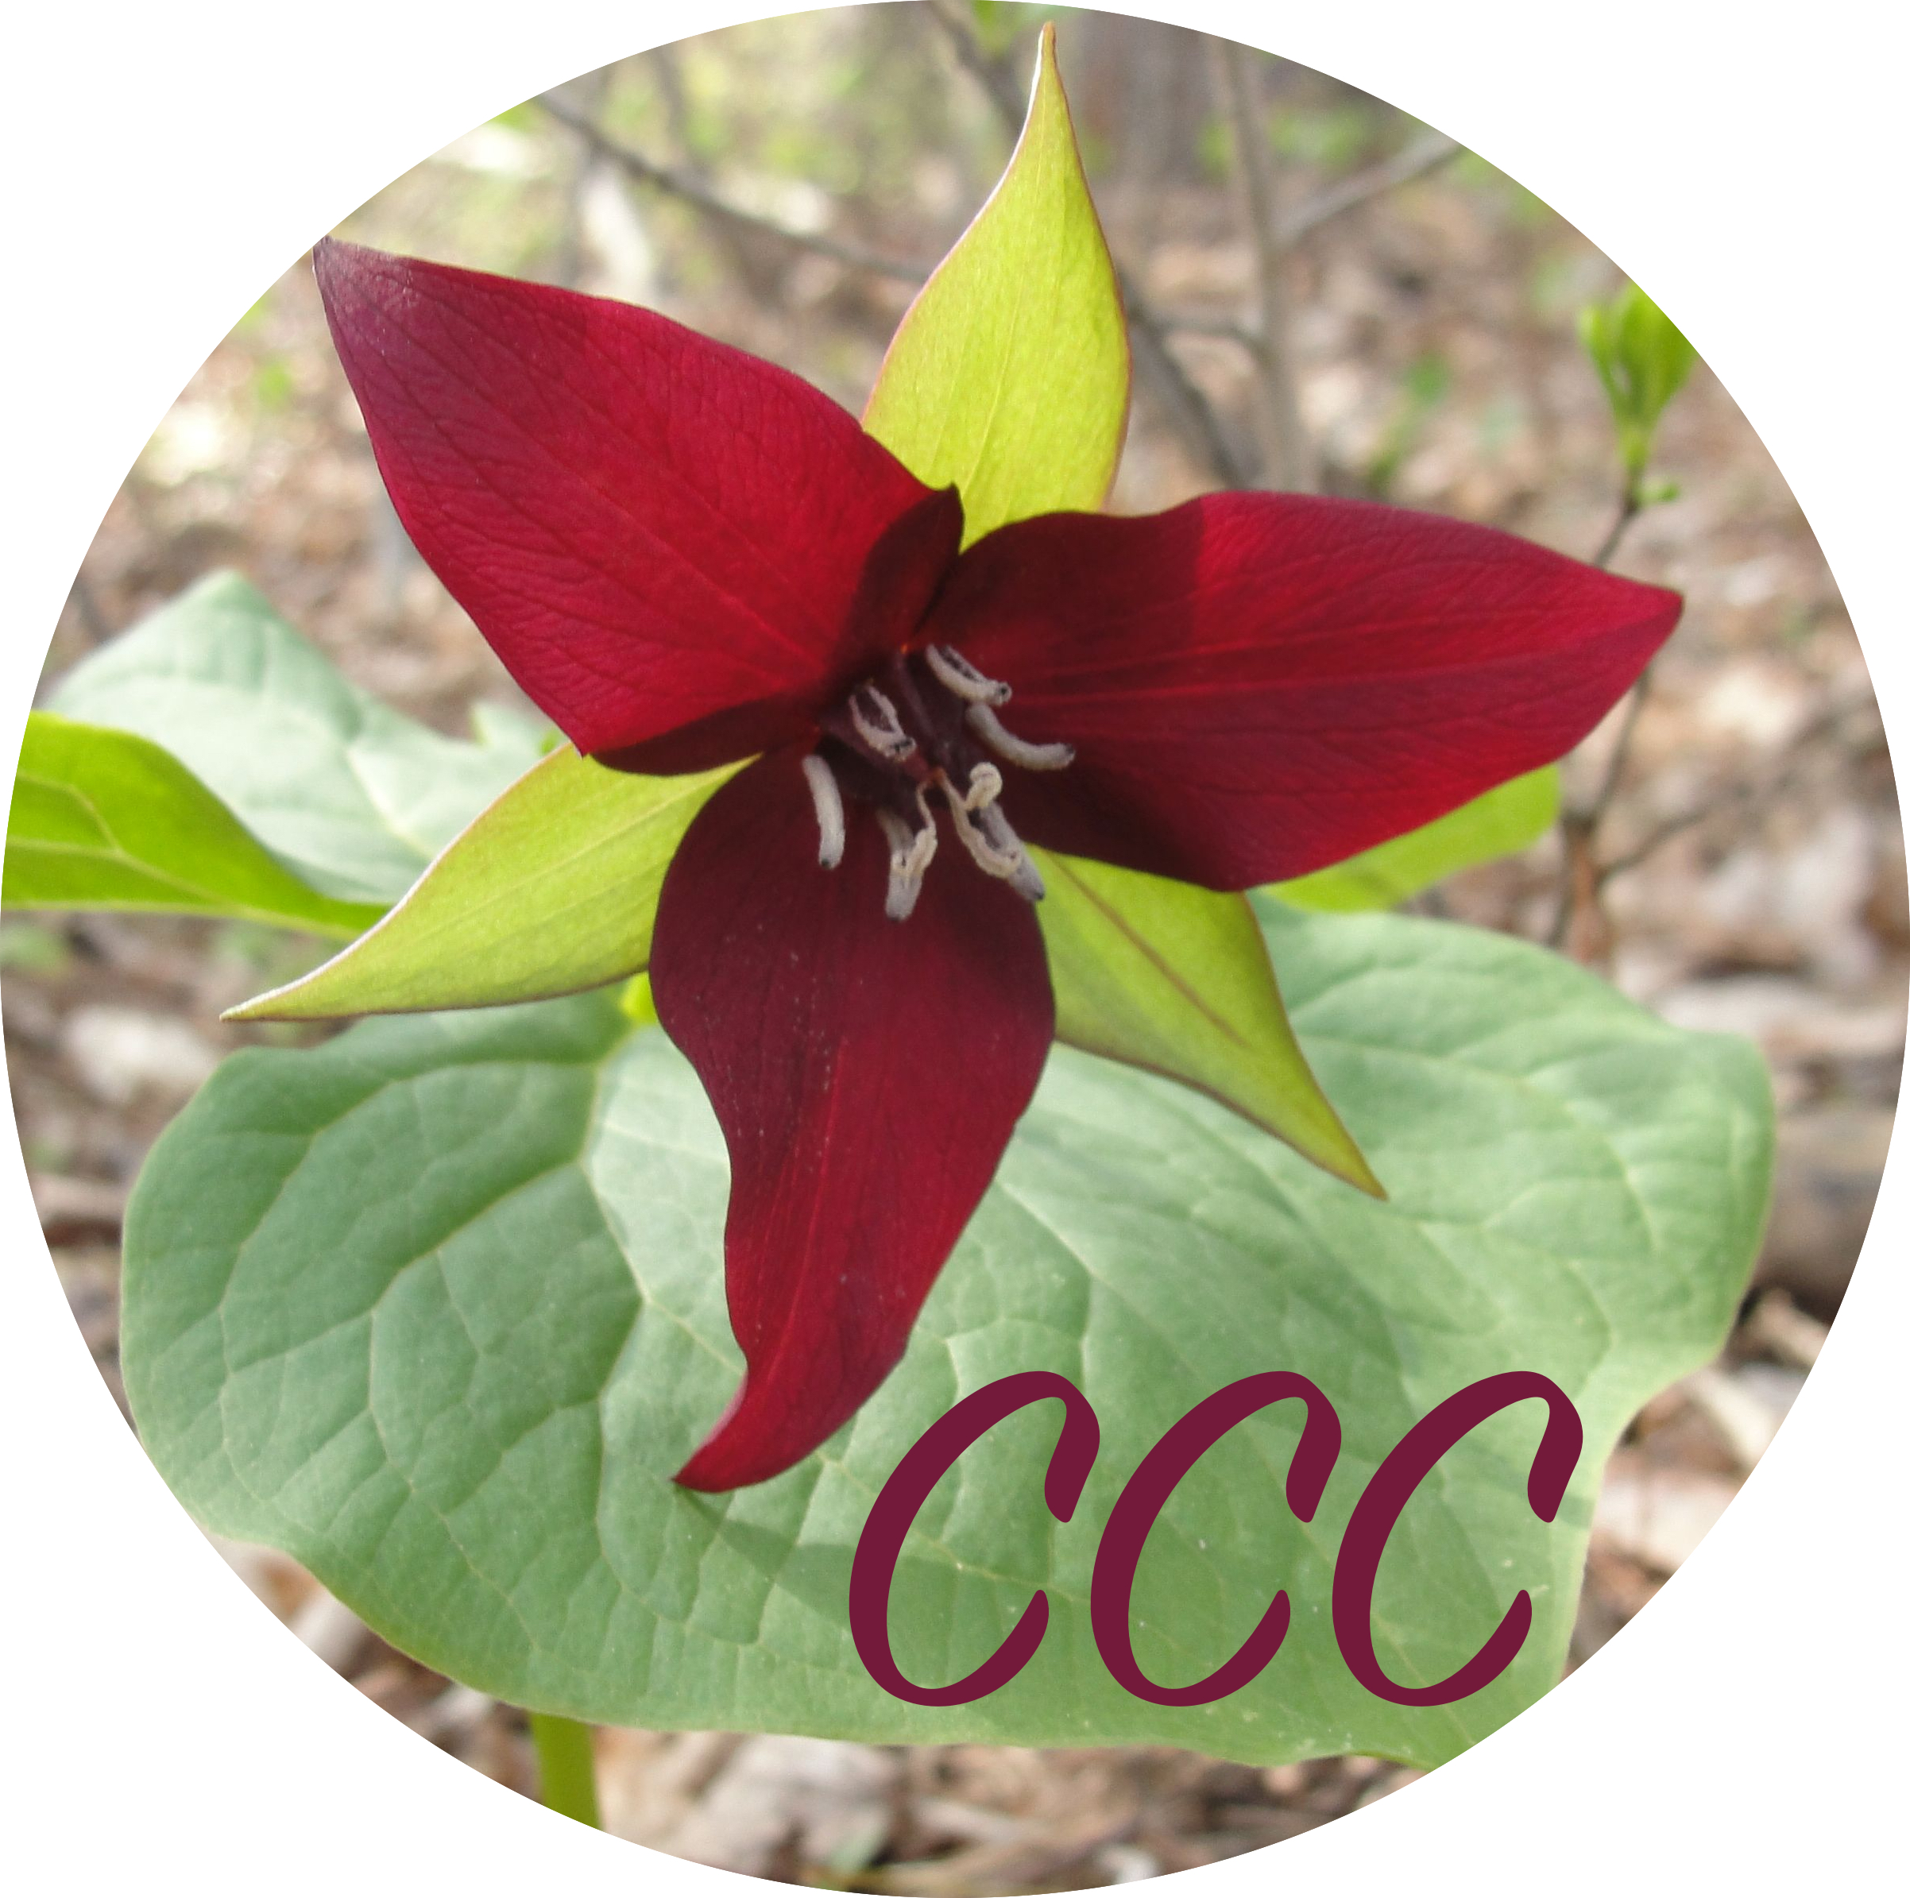
Rehearsal-Lesson Plan
Date:
Music Selection(s):

Standards Addressed (from Curriculum Plan--NAfME ensemble strand)
Creating:
Performing:
Responding:
Outcomes/Goals:
Knowledge:
Skills:
Dispositions:
Planned teaching strategies:

Assessment strategies:
Knowledge:
Skills:
Dispositions:

