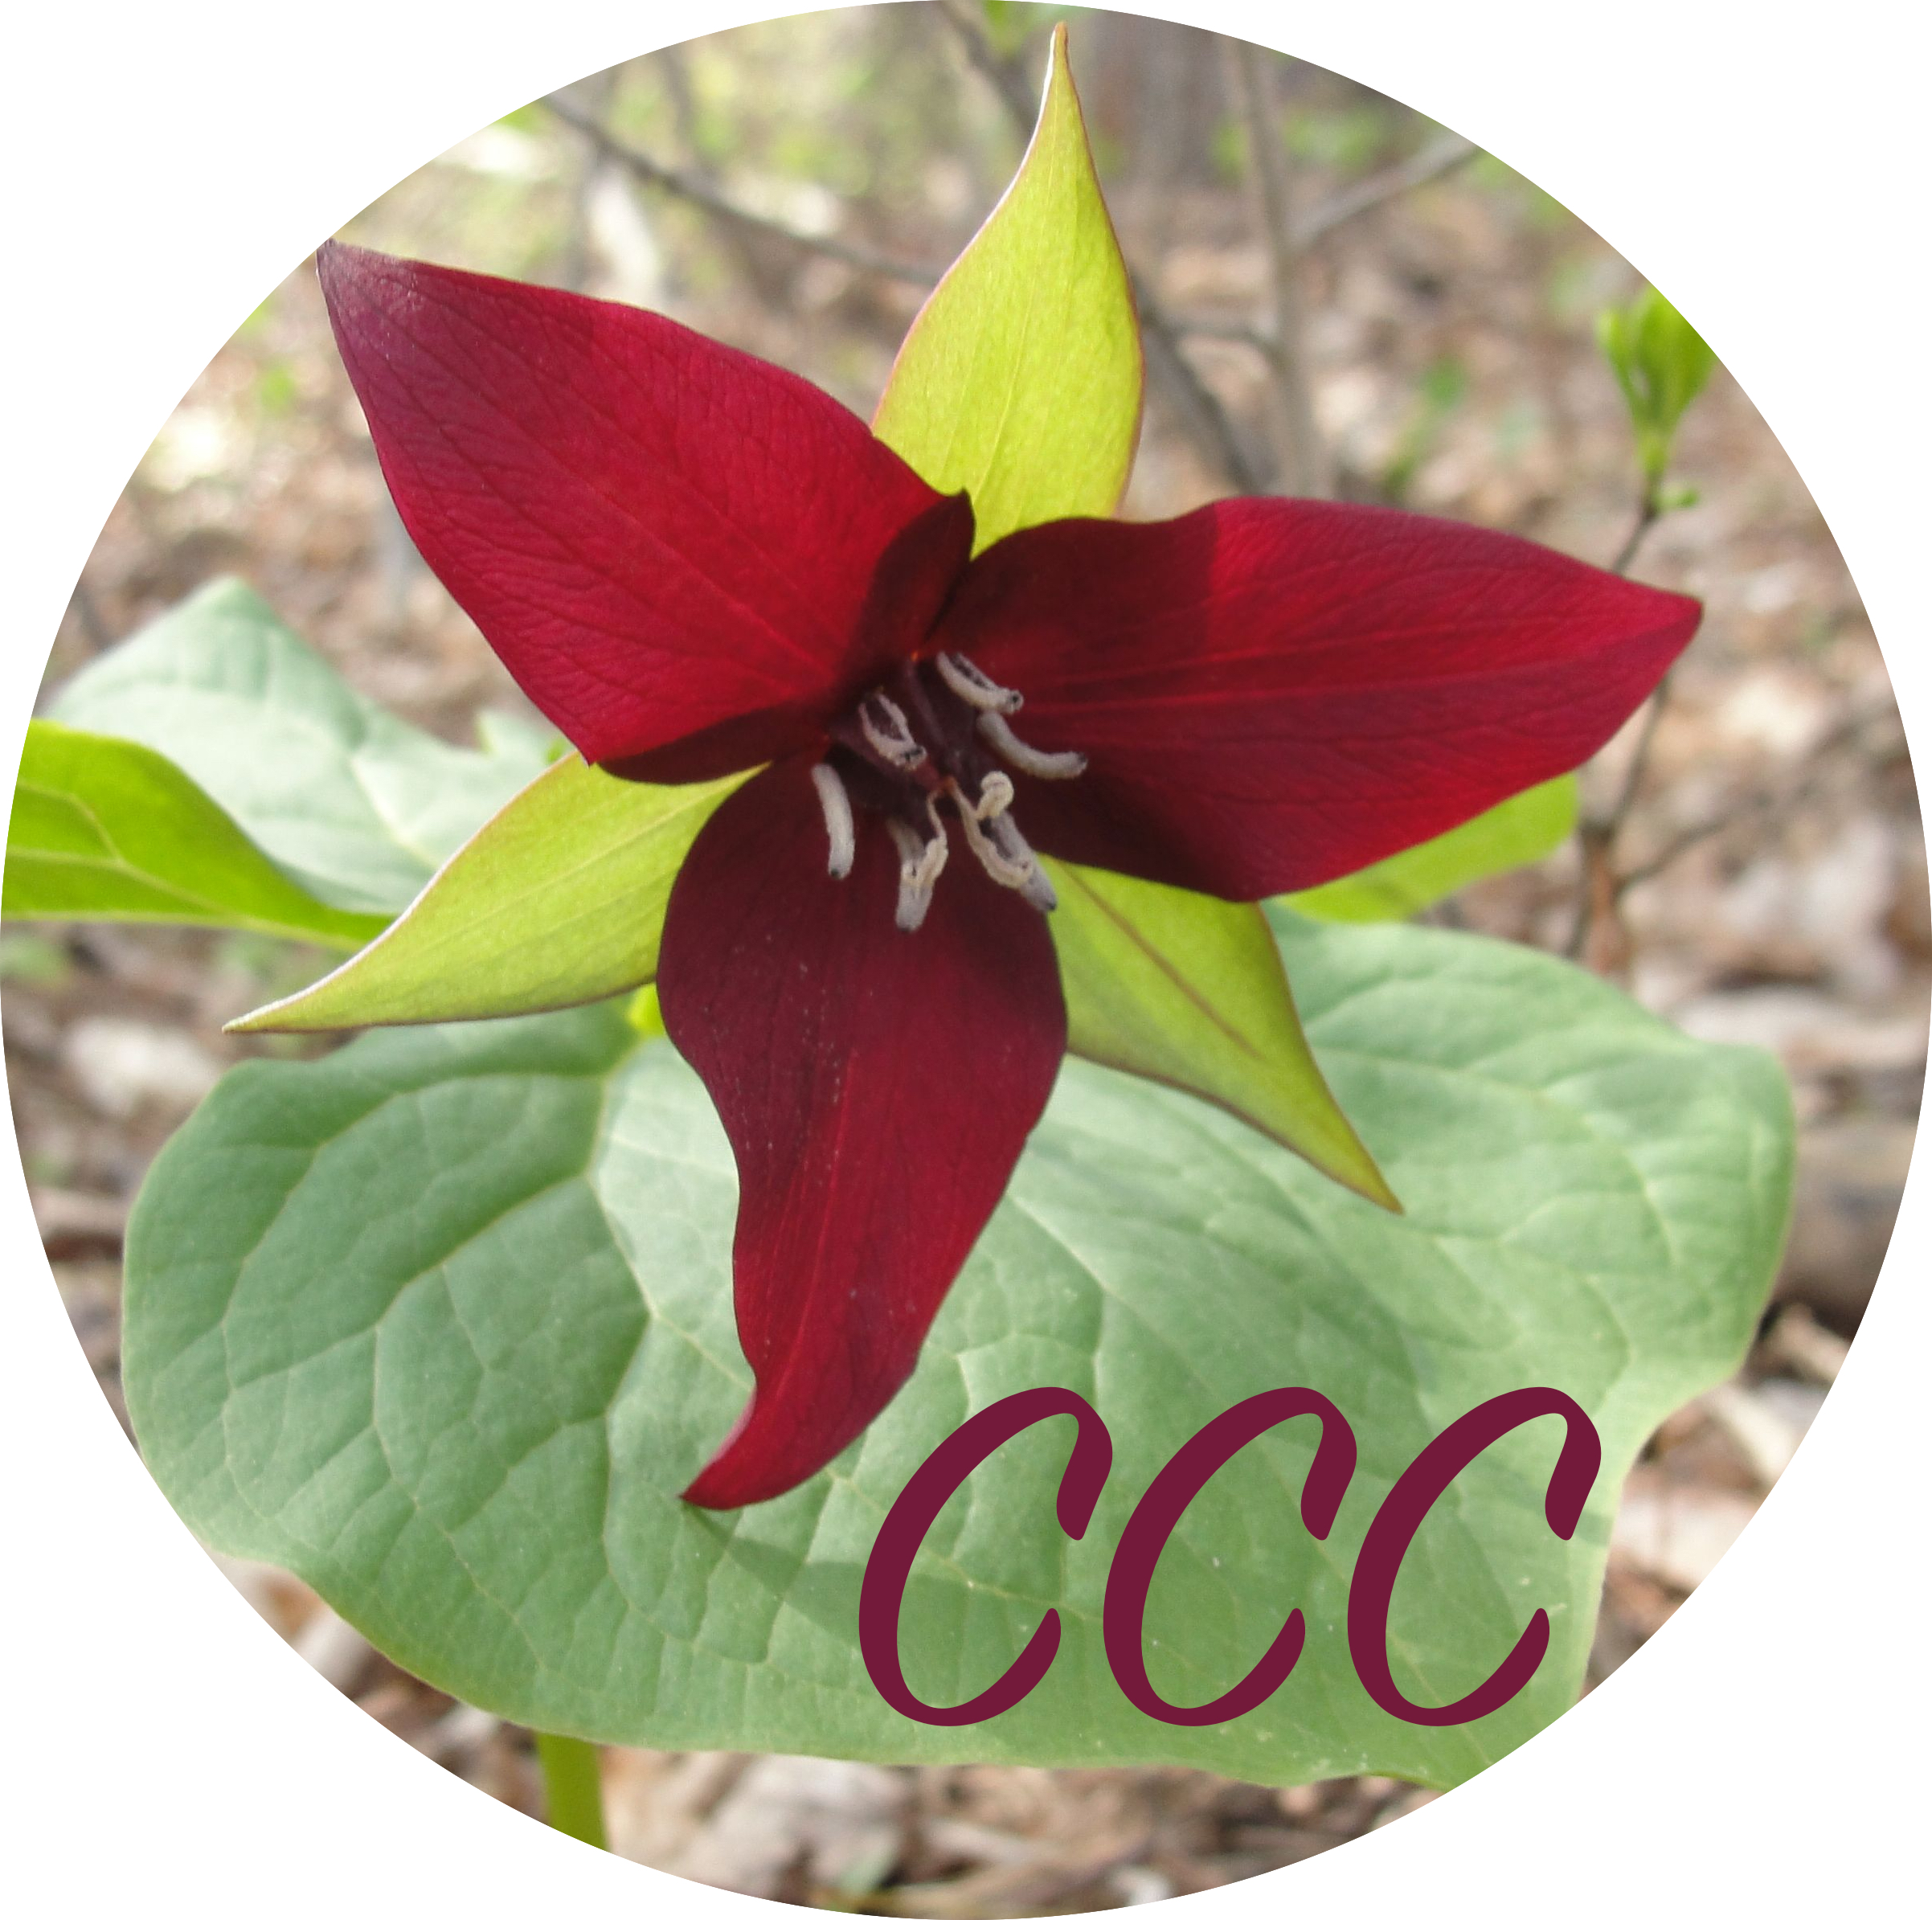
Musician Reflection
Now that you have presented your contribution and shared in our Informance, it is time to write a personal reflection. Please describe in detail your answers to the following questions below.

Name __________________________________________________________________________________
- What new musical knowledge have you learned?

- What new musical skills have you gained?

- What did you enjoy the most and why?

- Describe your progress in Performing music (singing, playing, demonstrating, leading, teaching, helping):

- Describe your progress in Creating new music (composing, improvising, experimenting, doodling):

- Describe your progress in Responding to music (listening, discussing, sharing, moving, drawing, dancing):

