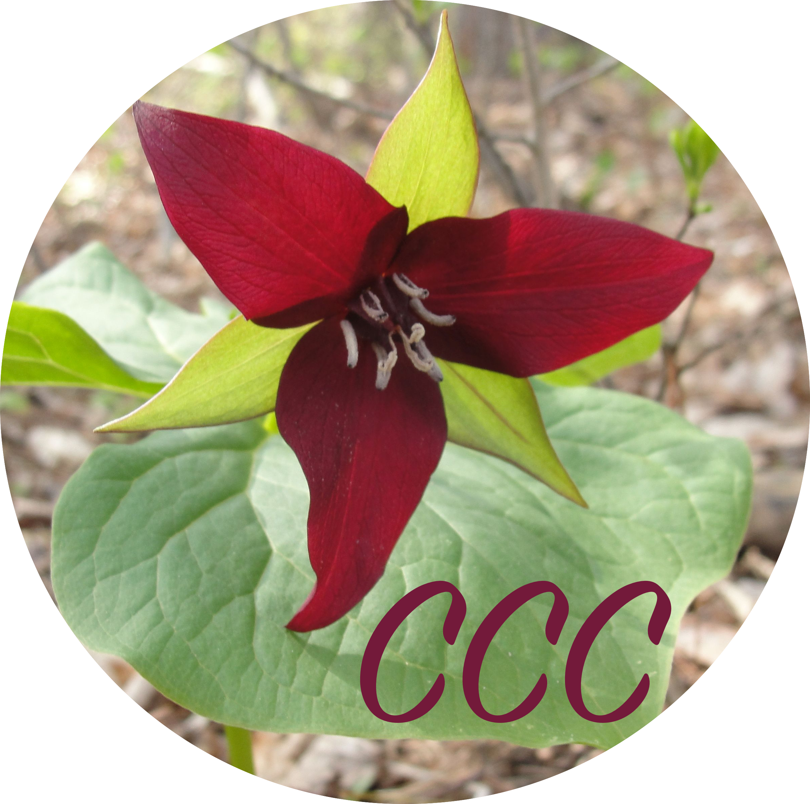
Musician Questionnaire

Name: _________________________________________________________________________________________
- What music do you enjoy listening to? __________________________________________________________________________________________________________________________________________________________________________________
- What songs do you like to sing? __________________________________________________________________________________________________________________________________________________________________________________
- What instruments can you play? __________________________________________________________________________________________________________________________________________________________________________________
- What piece of music have you enjoyed in our ensemble and why? __________________________________________________________________________________________________________________________________________________________________________________
- What activities do you enjoy most in our ensemble and why? __________________________________________________________________________________________________________________________________________________________________________________
- Name a favorite song, piece of music, or a musical style you would like to learn: __________________________________________________________________________________________________________________________________________________________________________________
- What would help you most in learning your favorite music? __________________________________________________________________________________________________________________________________________________________________________________
- Please indicate your first (1), second (2), and third (3) choice of activities:
_______Performing, singing, playing, demonstrating, leading, teaching, helping.
_______Responding, listening, discussing, sharing, moving, drawing, dancing.
_______Creating new music, composing, improvising, experimenting, doodling.

