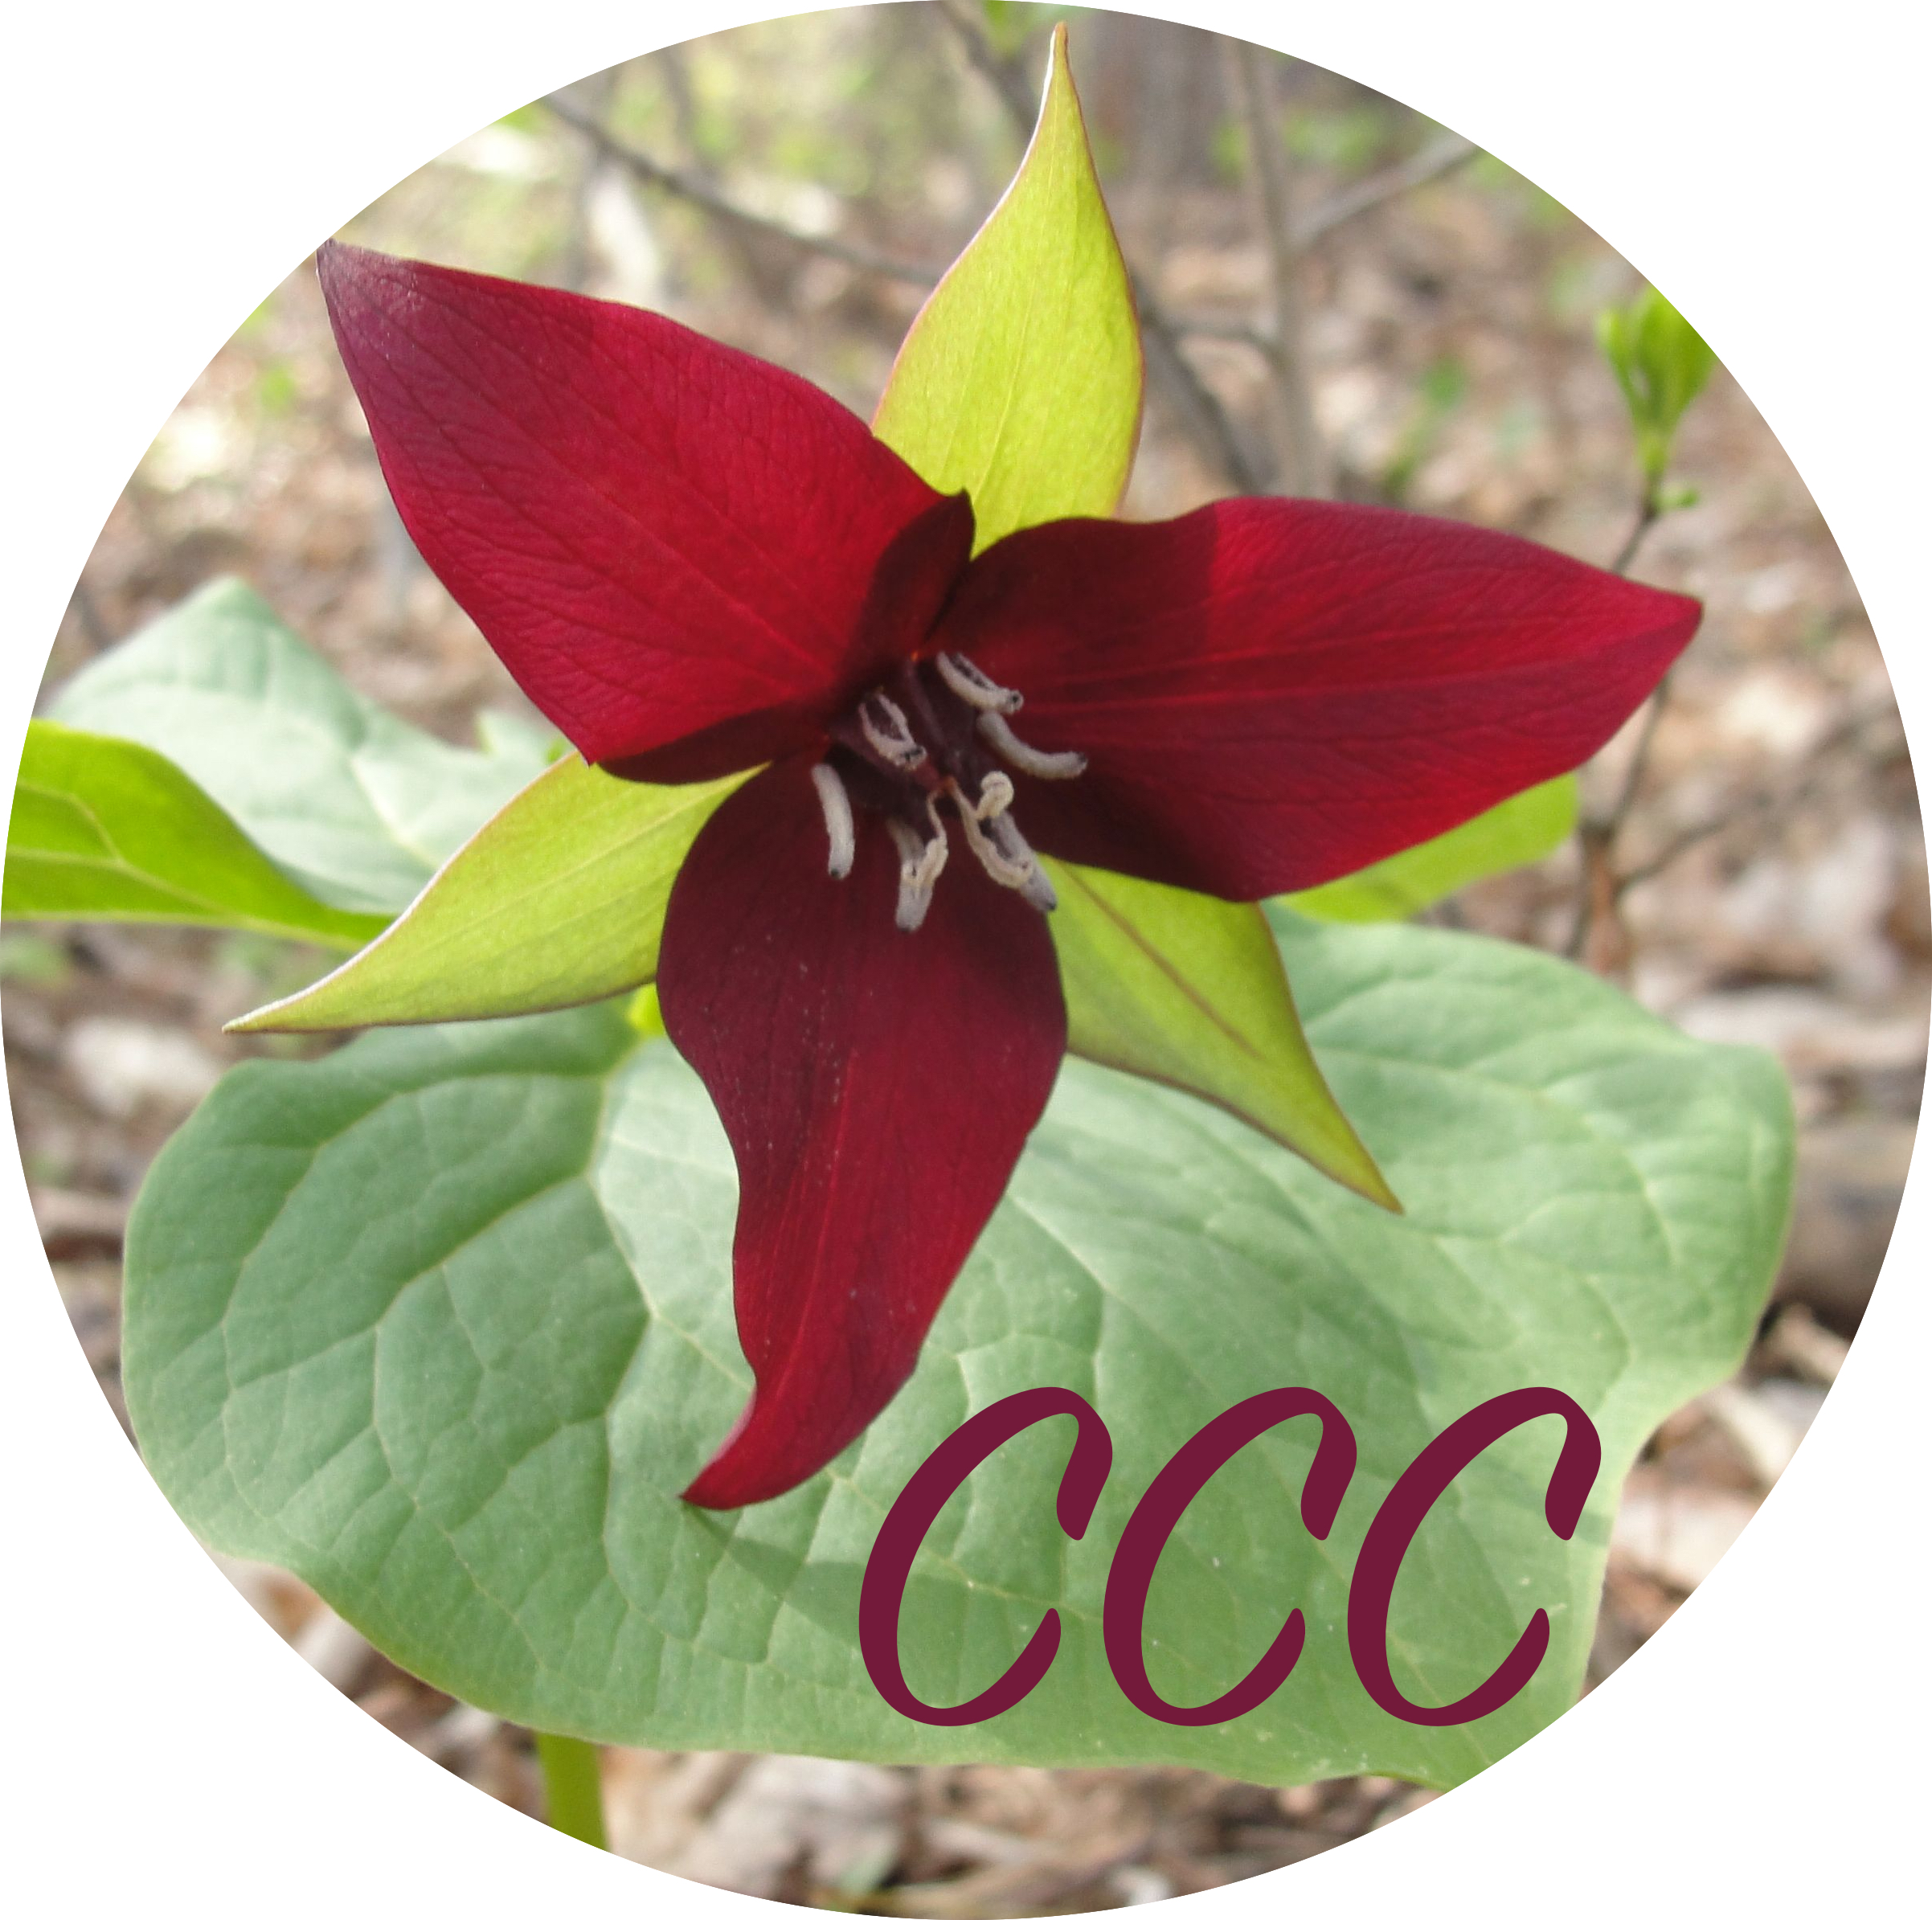
Curriculum Review
Semester _______________ Year ______________
Describe, code, or summarize the progress of each student in the following categories.

Name | Musical Skills | Knowledge | Dispositions | Performing | Responding | Creating

