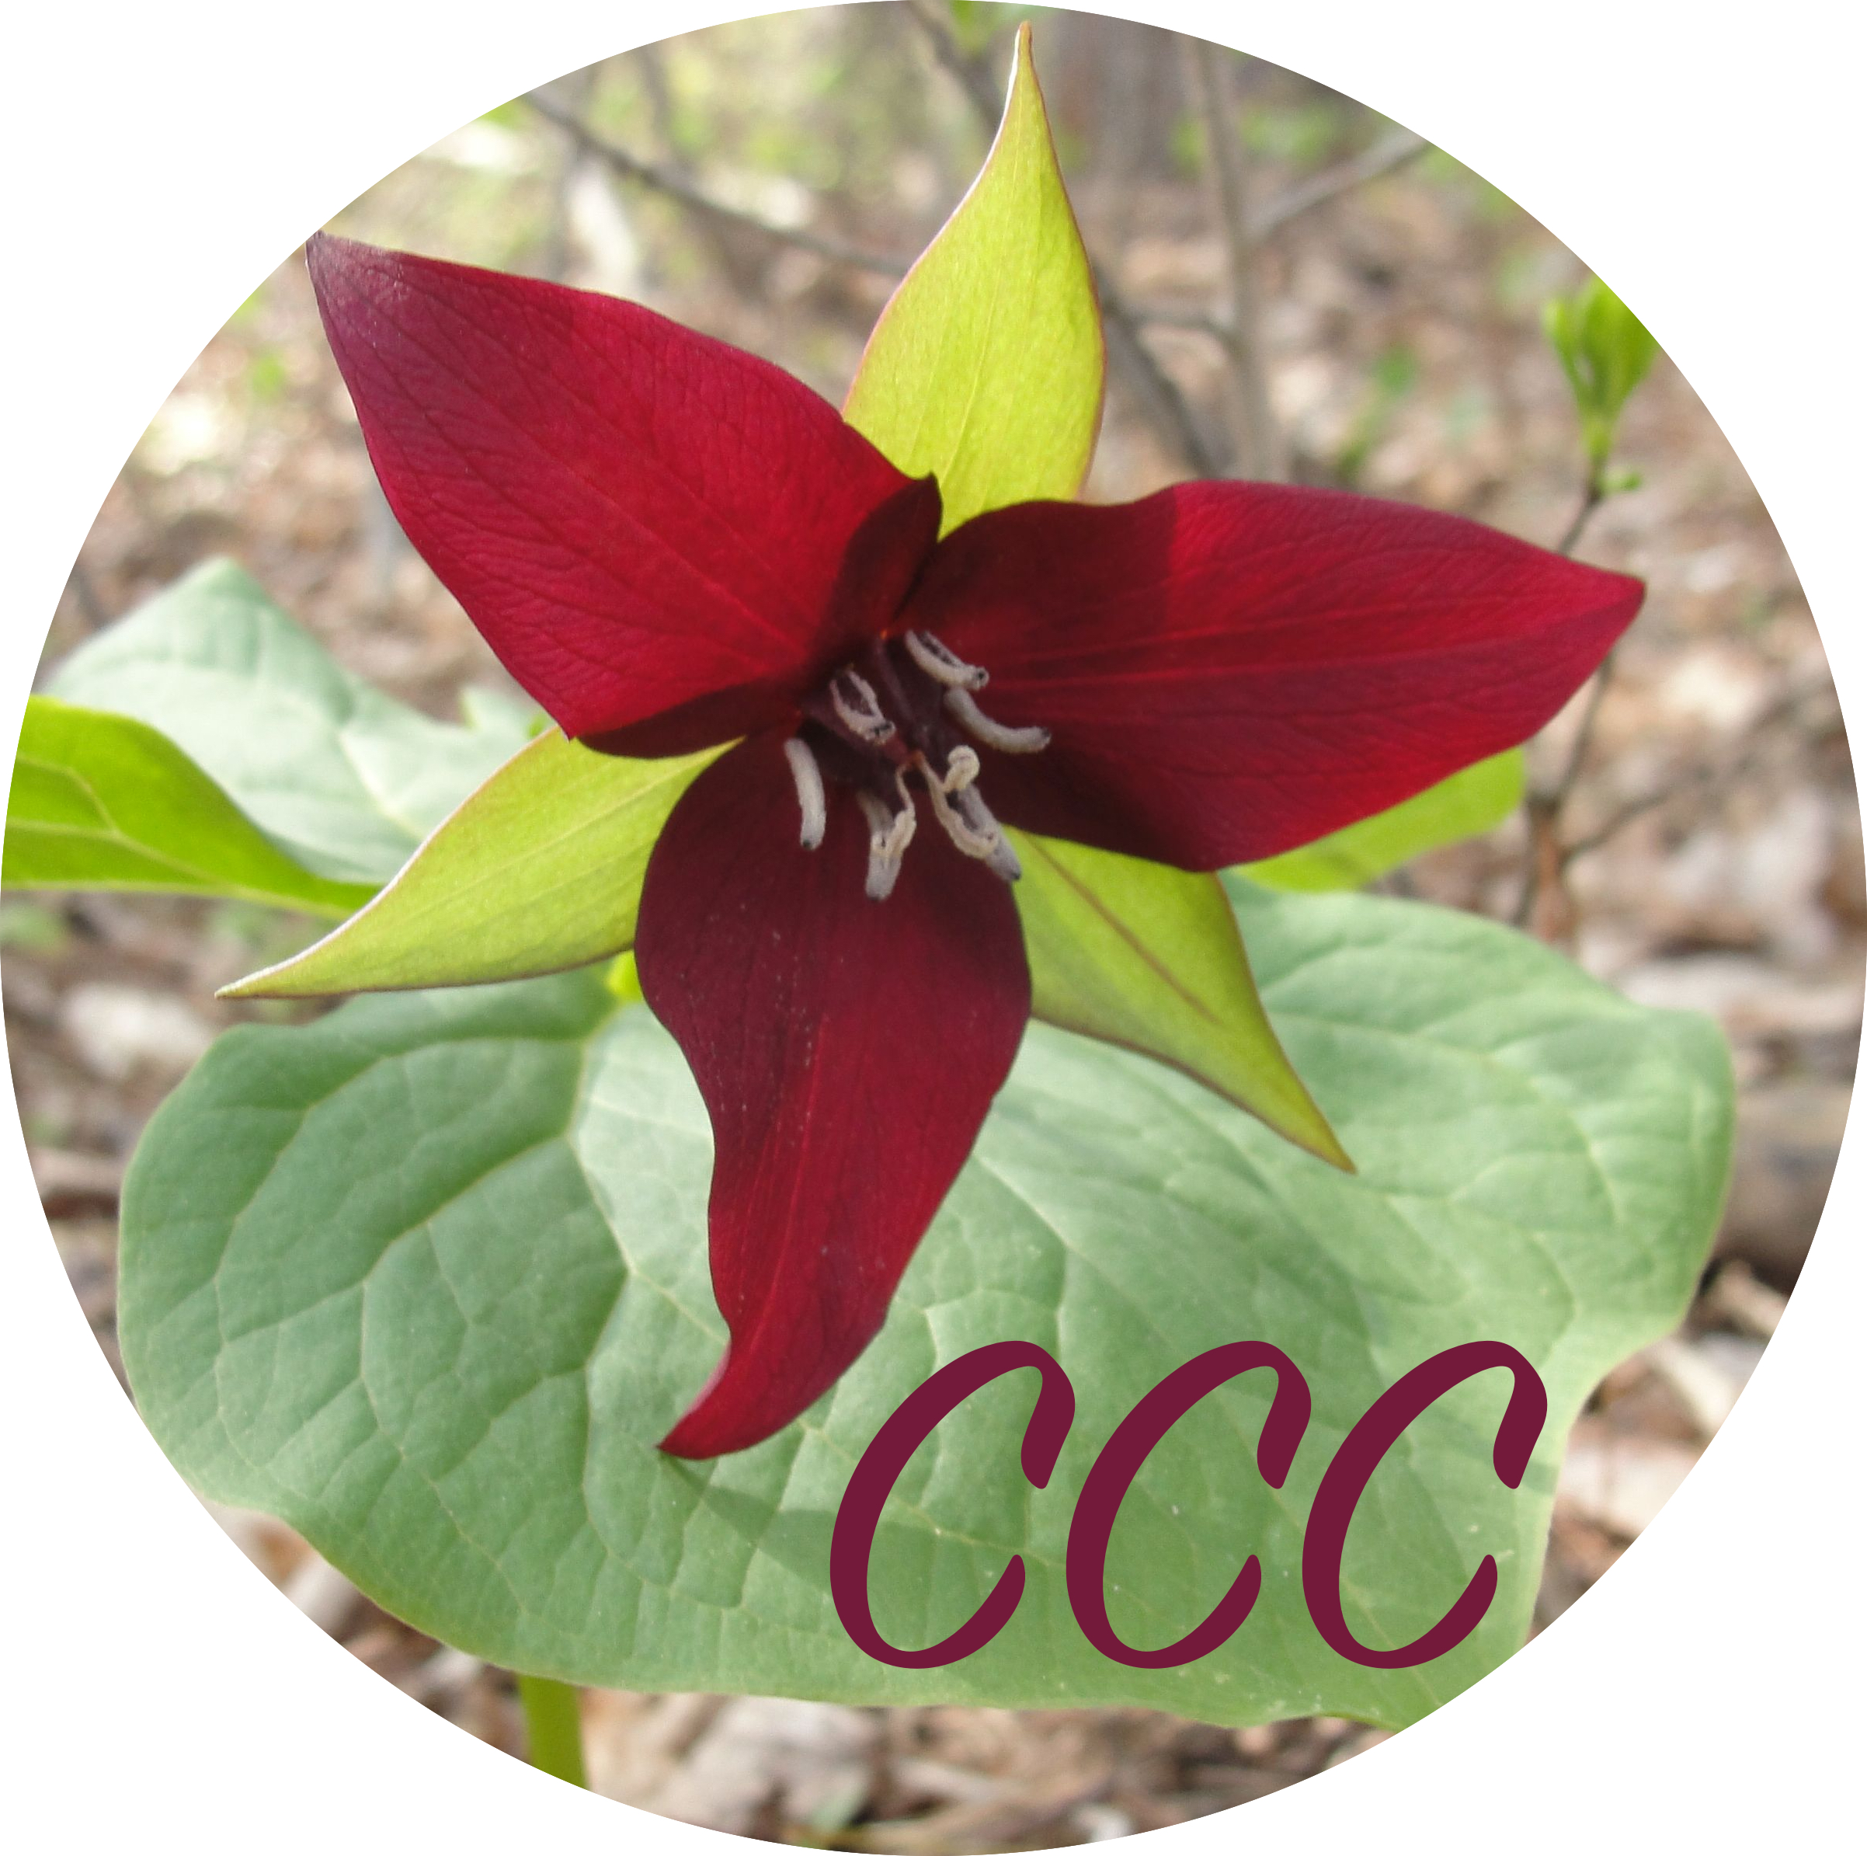
Curriculum Plan
Compare the chosen music literature with the results of your Curriculum Review, discussion with your administrator, and conversations/communications with teachers and parent organizations. Describe important information, curricular ideas, teaching approaches, etc. that will work well with teaching and sharing the chosen music.

Chosen Music | Musical Skills | Knowledge | Performing | Responding | Creating | School/Family

